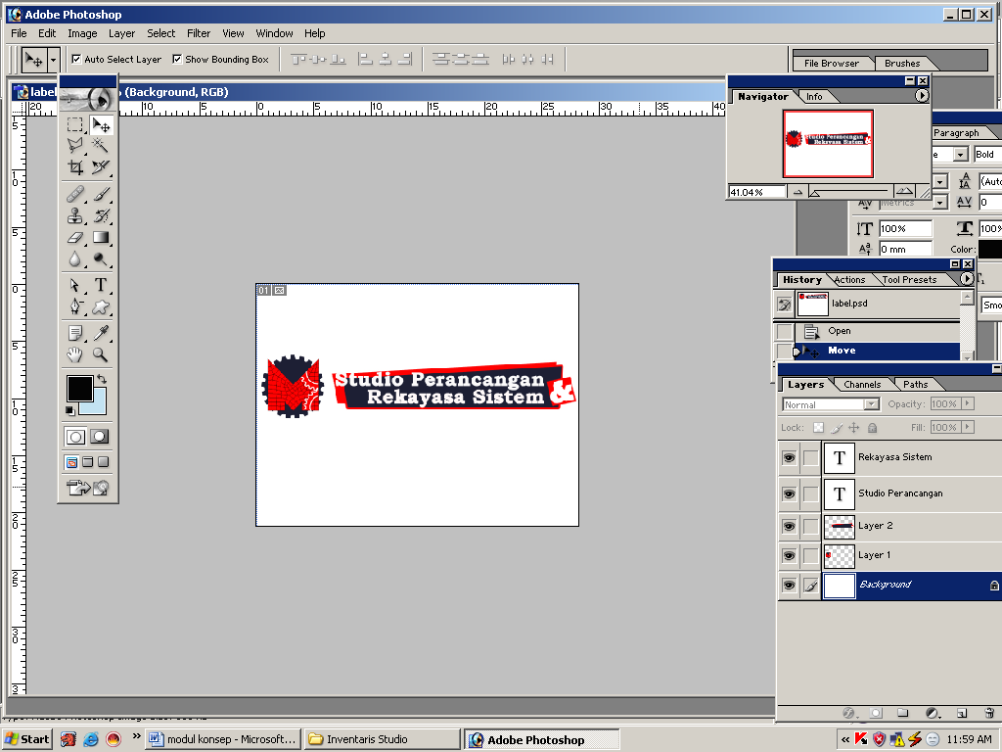STRUKTUR ORGANISASI

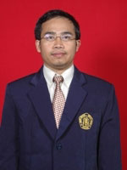STUDIO PERANCANGAN DAN REKAYASA SISTEM

**KEPALA LABORATORIUM**

Dr. Eng. Moch. Agus Choiron, ST.,MT

agus_choiron@ub.ac.id

082139249937

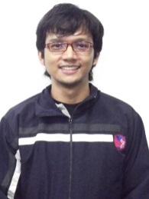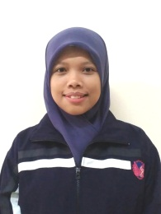

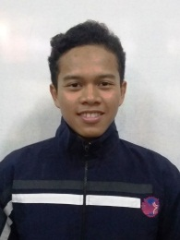

**MEMBER LABORATORIUM**

Fikrul Akbar Alamsyah ST.

fikrul@staff.ub.ac.id

0856496420005

**MEMBER LABORATORIUM**

Nafisah Arina Hidayati ST.,M.Eng.

nafarin_day@yahoo.com

085815427986

**KOORDINATOR ASISTEN**

**Achmad Syafi’udin**

achmad.alsinomany@gmail.com

**085749060527**

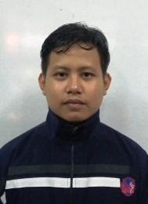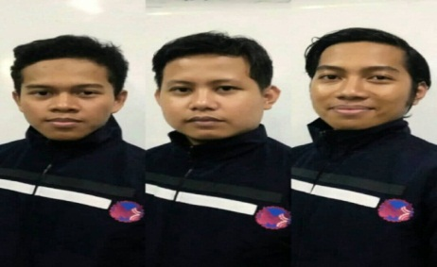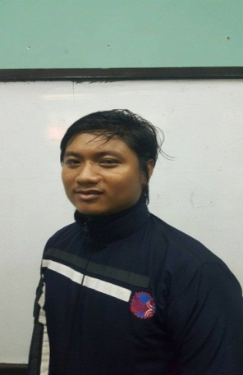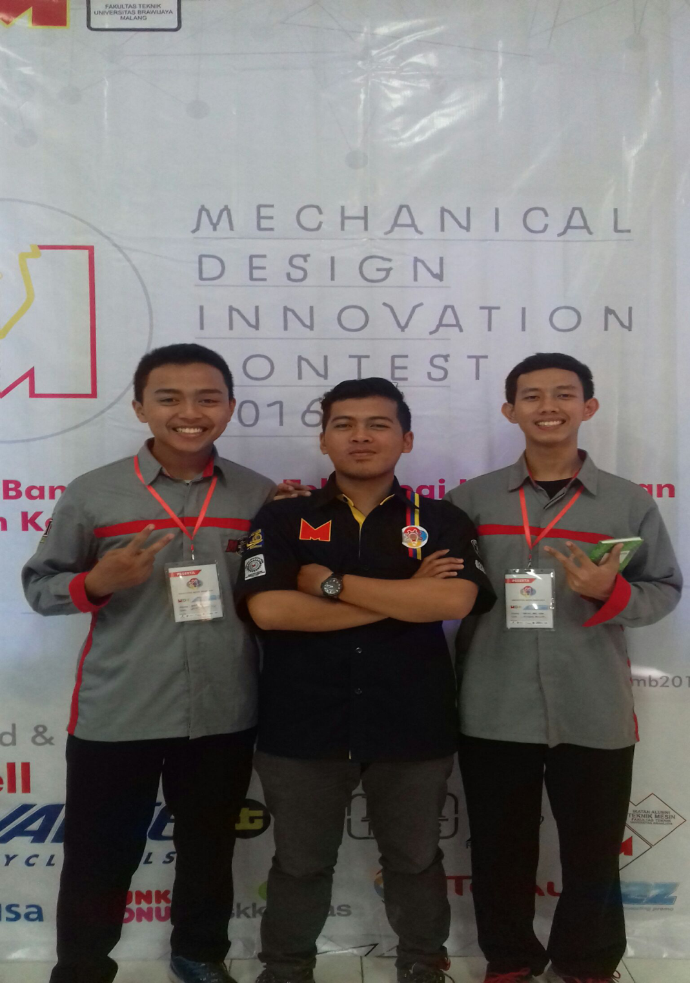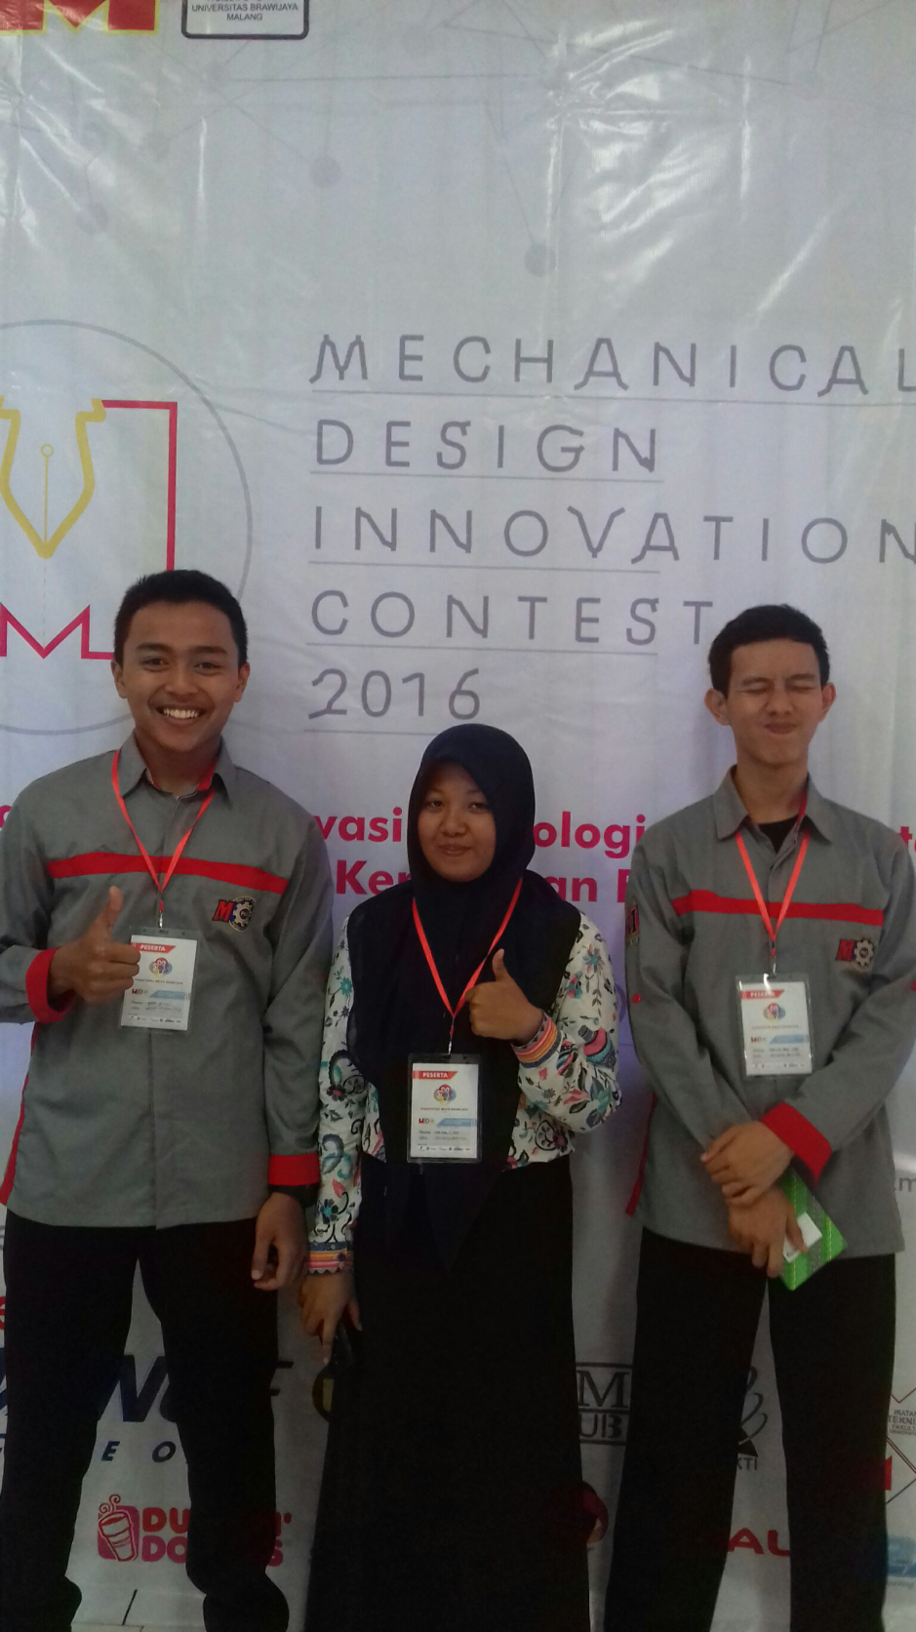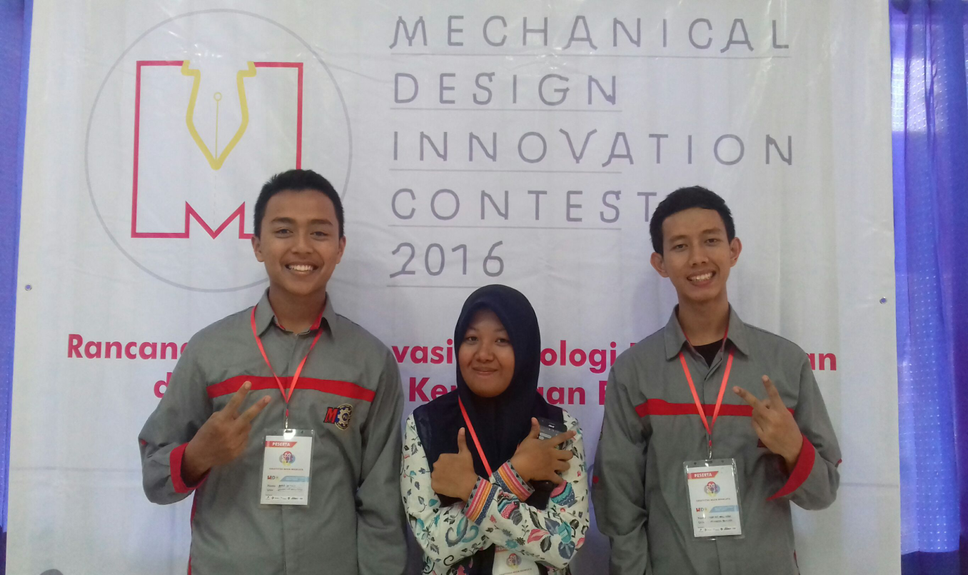

**BENDAHARA**

**Dewi Maria U**

[dewmariyau@gmail.com](mailto:dewmariyau@gmail.com)

08977448994

**MAINTENANCE**

**Muhamad Ainul Y**

yaqin740@gmail.com

082257653085

**ADMINISTRASI**

**Fitra Setiaji**

fitrasetiaji180297@gmail.com

085790536263

**ADMINISTRASI**

**Muhamad Ilyas**

[ilyascitizens@gmail.com](mailto:ilyascitizens@gmail.com)

081574309710

**SARPRAS**

**Isfan Apra A**

[isfansasha@gmail.com](mailto:isfansasha@gmail.com)

081331672983

**HUMAS**

**Kamaruddin**

kamaruddinsumenep@gmail.com

087859556818